XSLT

Extensible Stylesheet Language

From XML

To XML,HTML,text etc

XSLT is an XML based language

XSLT document is an XML document

Often with file extension .xsl

Similar to programming languages

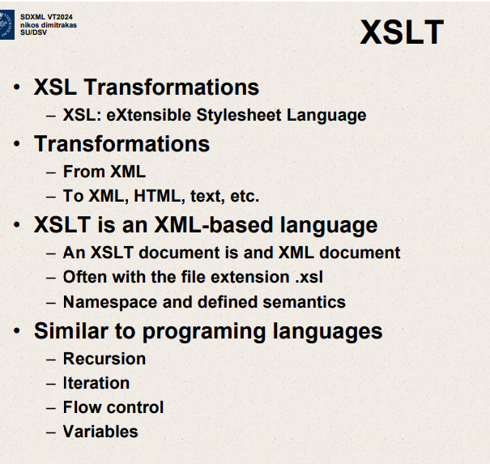

Recursion

Iteration

Flow control

variables

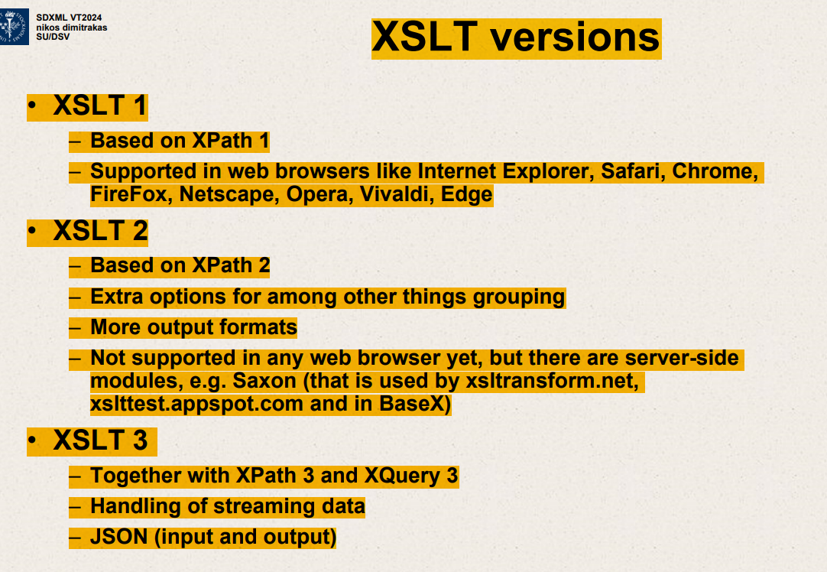

XSLT 1

Based on Xpath1

Supported in web browsers like Chrome,Firefox

XSLT 2

Based on Xpath2

Extra options for grouping

More output formats

XSLT 3

Together with Xpath3 and Xquery 3

Handling streaming data

JSON

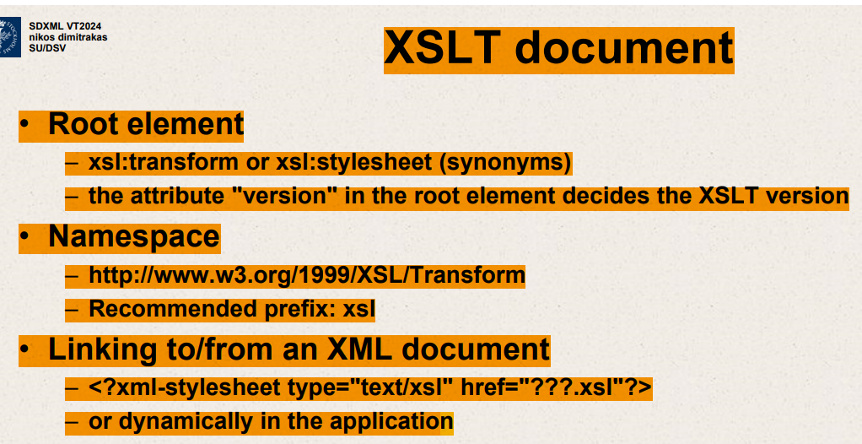

Root element

xsl:transform or xsl:stylesheet

they are synonyms

attribute version in root element decides XSLT version.

Namespace

Namespace is this URL

When we create namespace,we use xmlns: alias.

Recommended prefix:xsl

Linking to/from an XML document

When you open that XML document

<?xml-stylesheet type=”text/xsl” href=”” .xsl=”?”>

Or dynamically in the application

Call a function,here’s one input here’s another input.

XSLT -top level elements

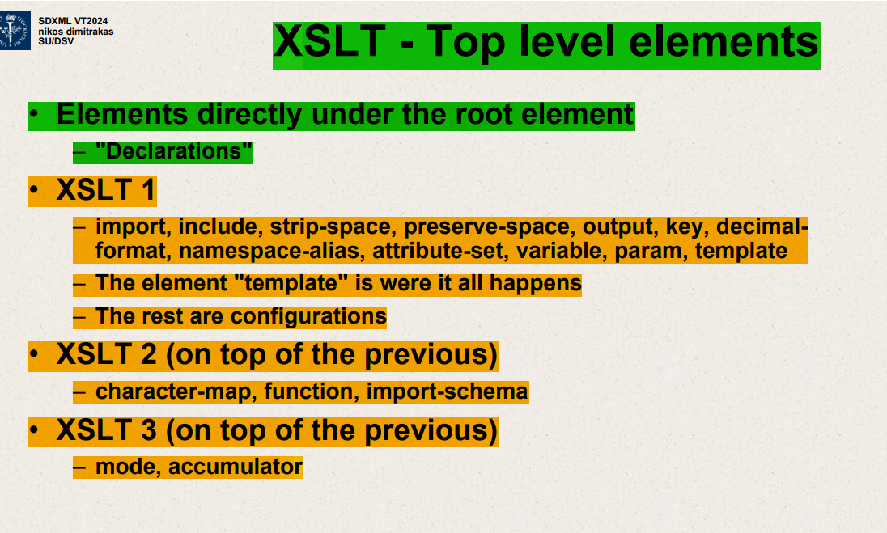

Templates- it’s similar to a procedure in programming language.

Template – All the work,programming,conditionss

Import include

XSL transformations

Transformations

From XML

To XML,HTML,text etc

XSLT is an XML based language

An XSLT document is an XML document

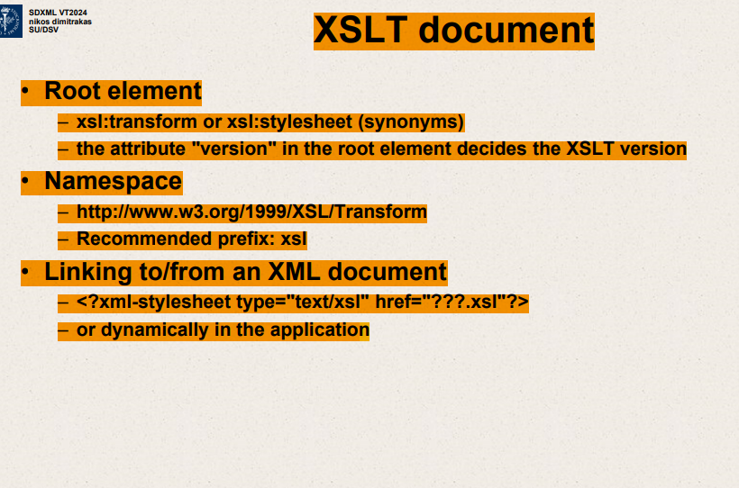

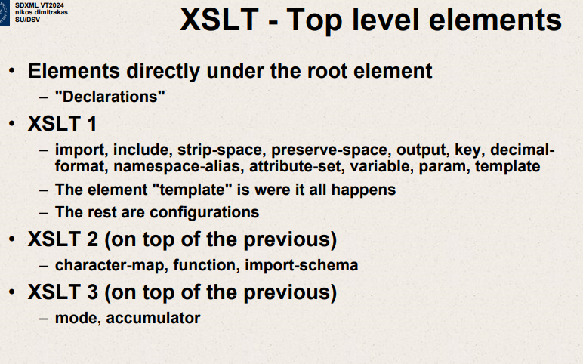

Elements directly under root element – “Declarations”

XSLT 1

Import,include,strip-space,preserve-space

Element – template where it all happens

Elements inside element “template”

XSLT 1

Node creation:element ,attribute,comment,processing-instruction

XSLT 2

On top of previous

character-map,function,import-schema

XSLT 3

Mode,accumulator

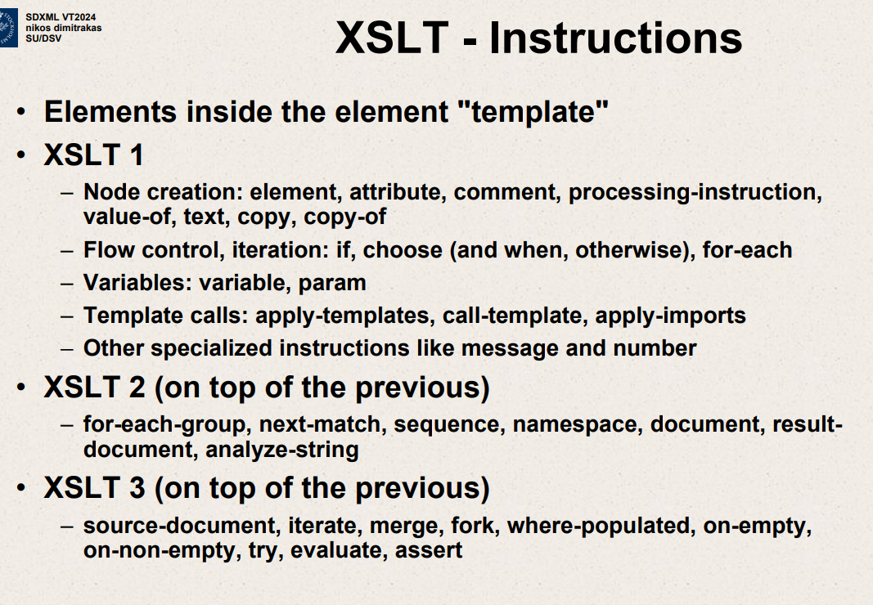

Elements inside element “template”

XSLT 1

Node-creation;element;attribute;comment;processing-instruction

Variables: variable,param

XSLT 2

For each group ,next-match,sequence,namespace,document

XSLT 3

Source-document,iterate,merge,fork ,where-populated,on-empty,on-non-empty

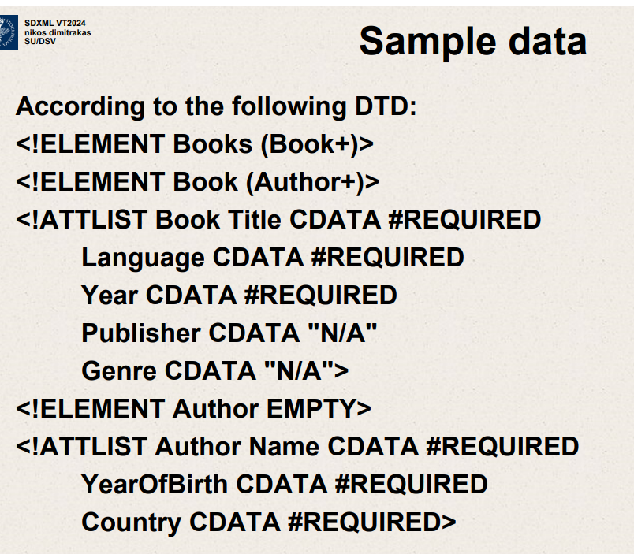

Flow control and iteration – same in any other language

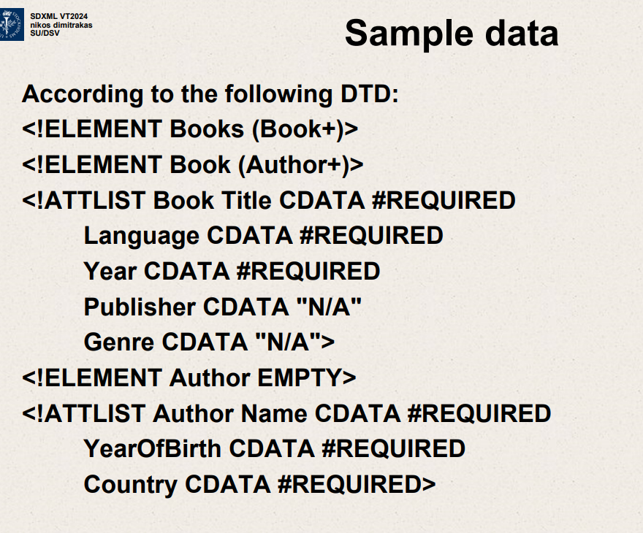

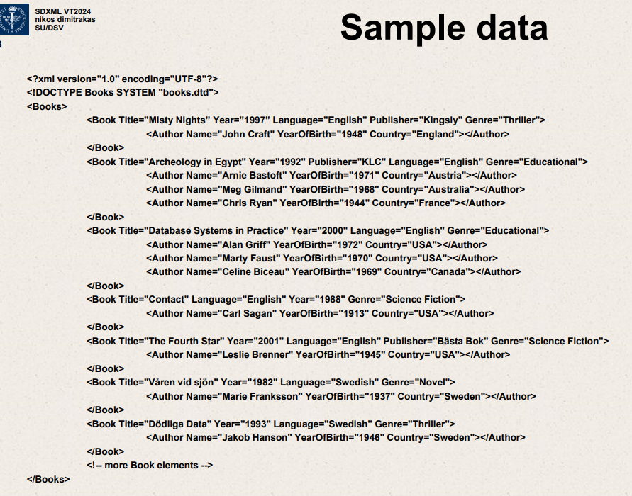

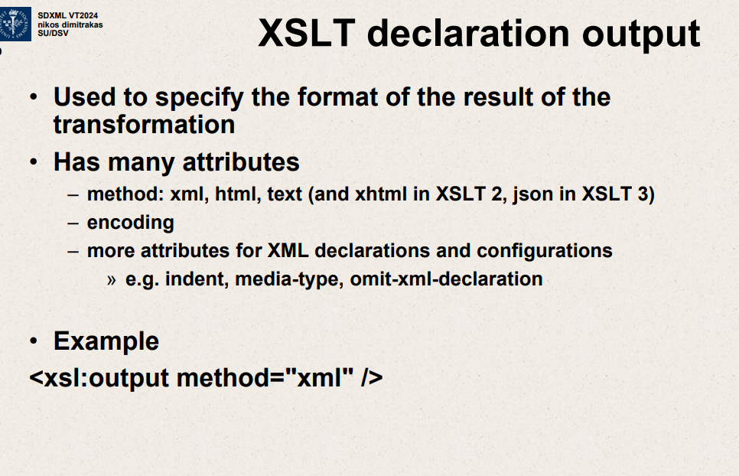

Used to specify the format of the result of the transformation.

Has many attributes

Method:xml,html,text

Encoding

<xsl:output method=”xml”>

Top level elements

Then instructions under Template

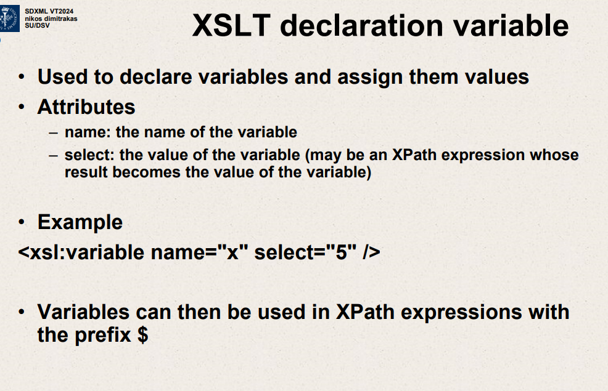

XSLT declaration variable

Used to declare variables and assign them values

Attributes – name: the name of the variable – select: the value of the variable (may be an XPath expression whose result becomes the value of the variable)

Example

Variables can then be used in XPath expressions with the prefix $

<xsl:variable name=”x” select=”5”>

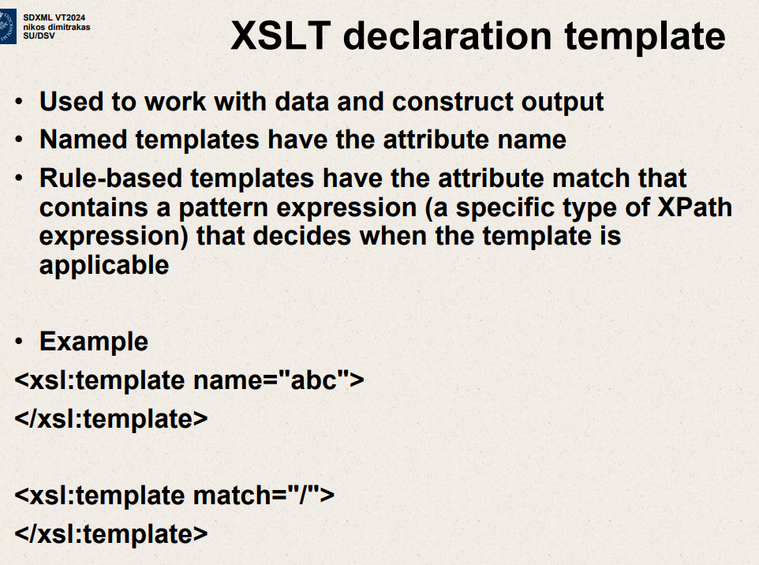

Templates - Used to work with data and construct output.

Named templates have attribute name.

Rule based templates have attribute match that contains a pattern expression (type of Xpath expression) that decides when template is applicable

<xsl:template name=”abc”>

</xsl:template>

Rule based templates

<xsl:template match=”/”>

</xsl:template>

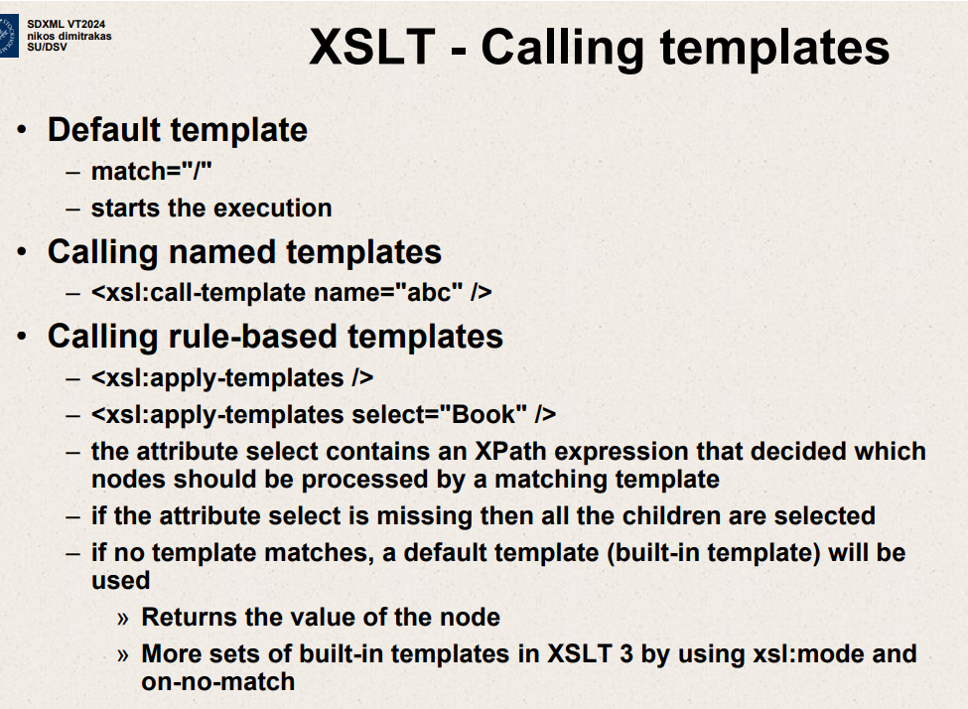

Default template

Match=”/”. Starts the execution

Calling named templates

<xsl:call-template name=”abc”>

Calling rule based templates

<xsl:apply-templates/>

<xsl:apply-templates select=”Book”/>

Attribute select contains an XPath expression that decides which nodes should be processed by matching template.

If attribute select is missing all children are selected.

XSLT: Constructor instructions

Element 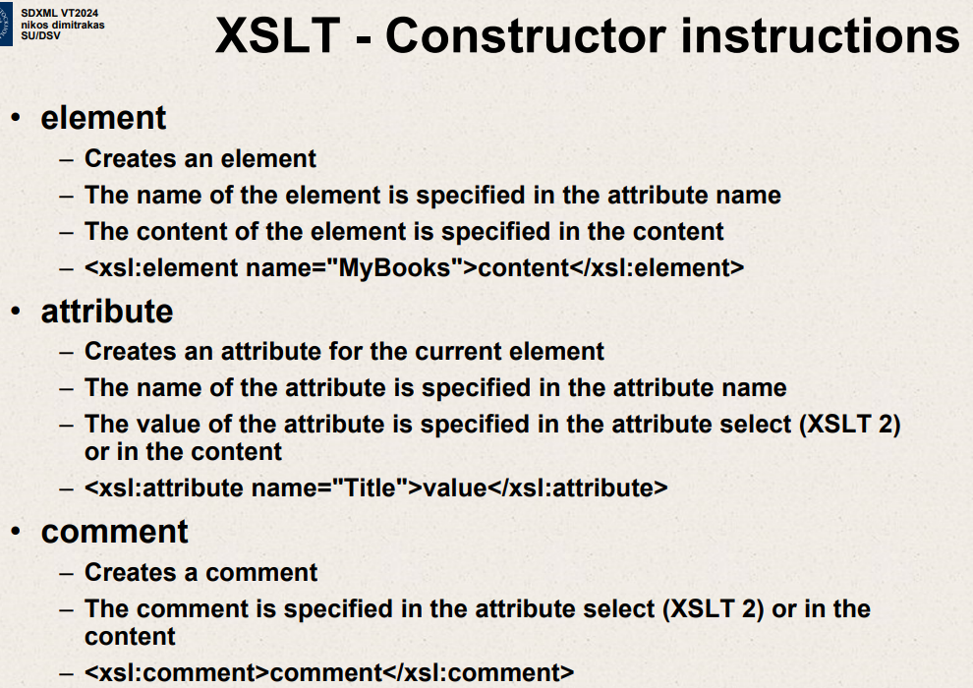

Creates an element

Name of element is specified in attribute name.

Content of element is specified in content

<xsl:element name=”MyBooks”>content</xsl:element>

Attribute

Creates an attribute for the current element.

Name of attribute is specified in attribute name.

Value of attribute specified in attribute select or in the content.

<xsl:attribute name=”Title”>value</xsl:attribute>

<xsl:comment>comment</xsl:comment>

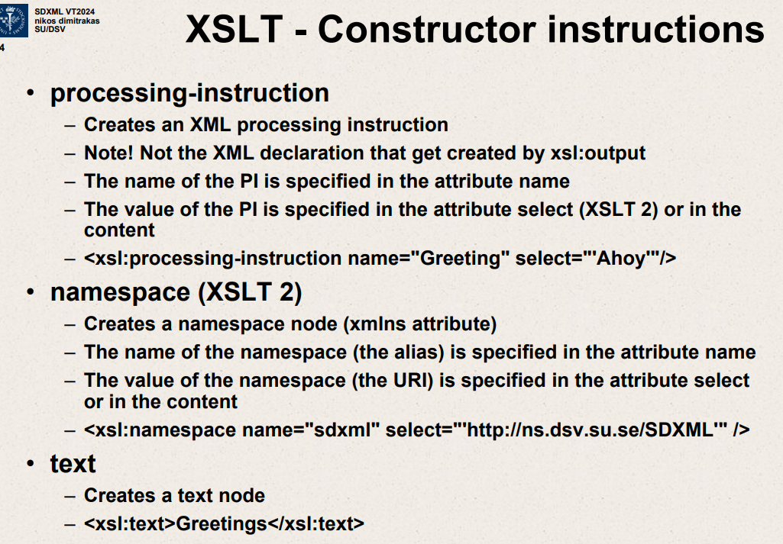

processing – instruction

Creates an XML processing instruction

Not the XML declaration that get created by xsl:output

Name of the PI(processing-instruction) is specified in the attribute name

Value of the PI is specified in the attribute select or in the content

<xsl: processing-instruction name=”Greeting” select=”Ahoy”>

namespace

Creates a namespace node(xmlns attribute)

Name of namespace(alias) is specified in attribute name.

Value of namespace(URI) specified in attribute select or in the content.

<xsl:namespace name=”sdxml” select=<http://ns.dsv.su.se/SDXML>/>

Text

Creates a text node

<xsl:text>Greetings</xsl:text>

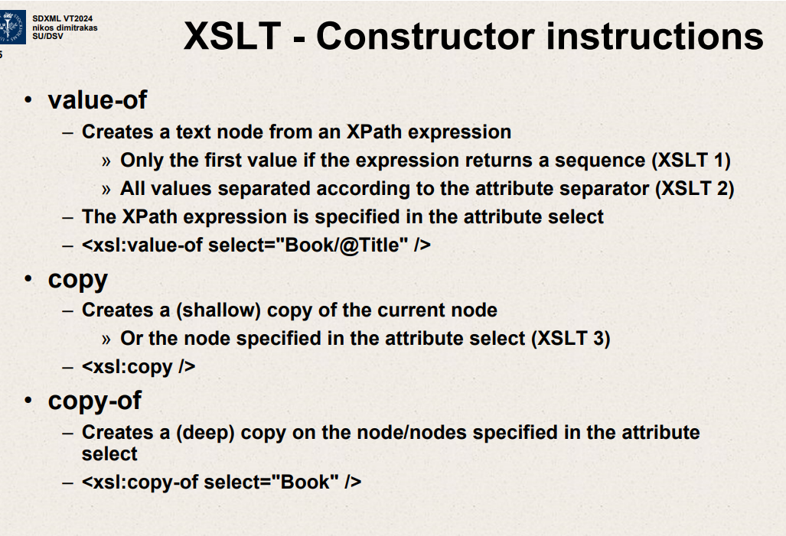

Value-of

Creates a text node from an Xpath expression

Only 1st value if expression returns a sequence.

All values separated according to attribute separator.

<xsl:value-of select=”Book/@Title”>

Copy

Creates a shallow copy of current node

Or node specified in attribute select.

<xsl:copy/>

Copy-of

Creates deep copy on nodes specified in attribute select.

<xsl:copy-of select:Book>

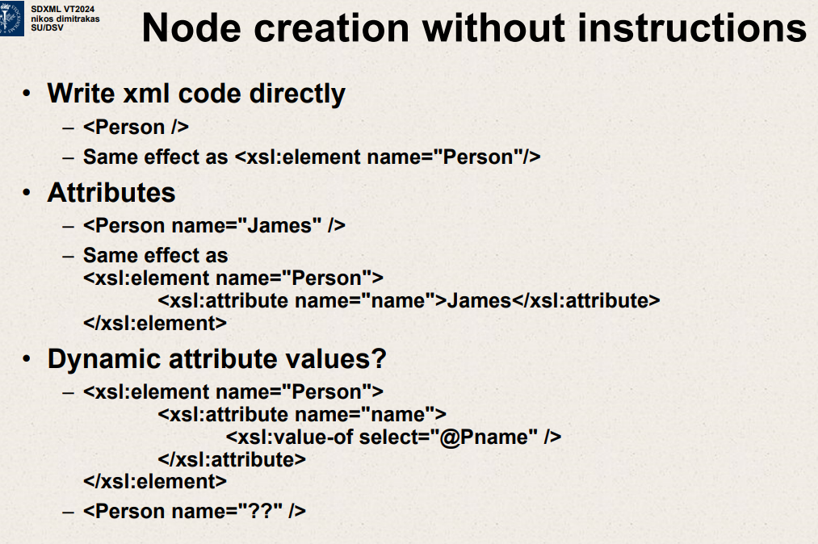

<Person/>

Same as <xsl:element name=”Person”>

<Person name="James”>

<xsl:element name=”Person”>

<xsl:attribute name=”name”> James</xsl:attribute>

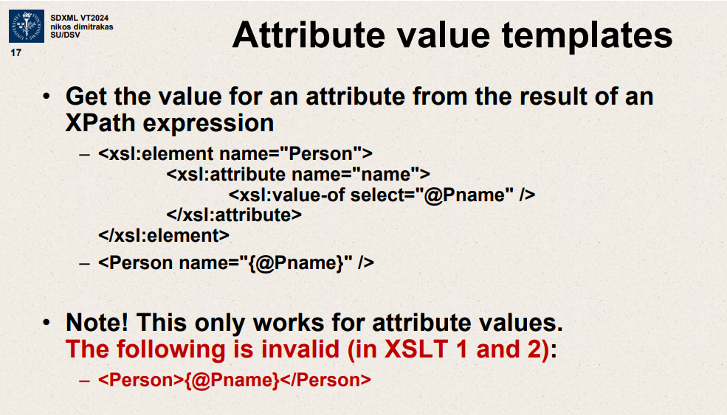

Get value of attribute from result of an xpath expression

<xsl:element name=”person”>

<xsl:attribute name=”name”>

<xsl:value-of select=”@Pname”/> </xsl:attribute>

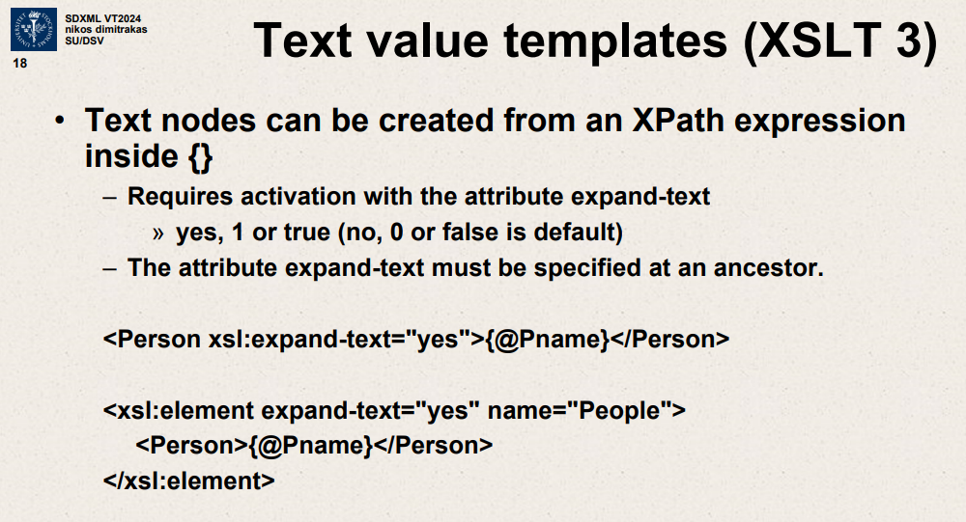

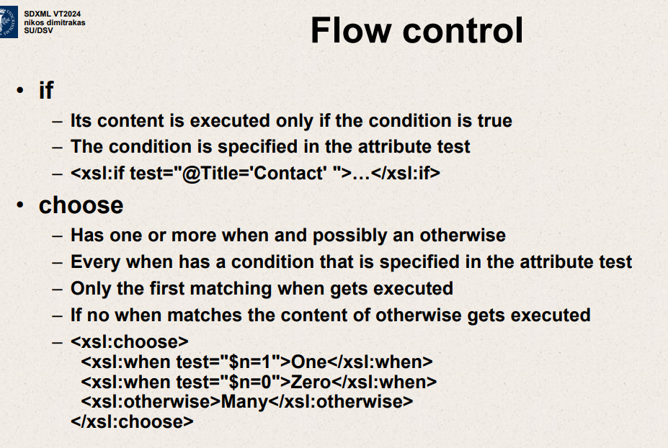

If -Its content executed only if condition is True

Condition is specified in attribute test

<xsl:if test=”@Title=’Contact’”> </xsl:if>

Choose

Has one or more when ,possibly an otherwise

Every when has condition specified in attribute test.

Only first matching when gets executed.

If no when matches content of otherwise gets executed.

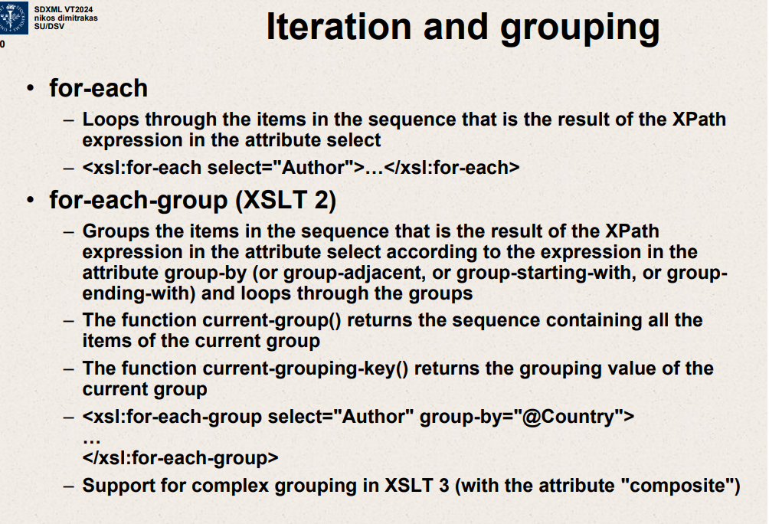

for-each

Loops through items in the sequence that is result of Xpath expression in attribute select.

<xsl:for-each select=”Author”> </xsl:for-each>

<xsl:for-each-group select=”Author” group-by=”@Country”>

</xsl:for-each-group>

Support for complex grouping in XSLT 3

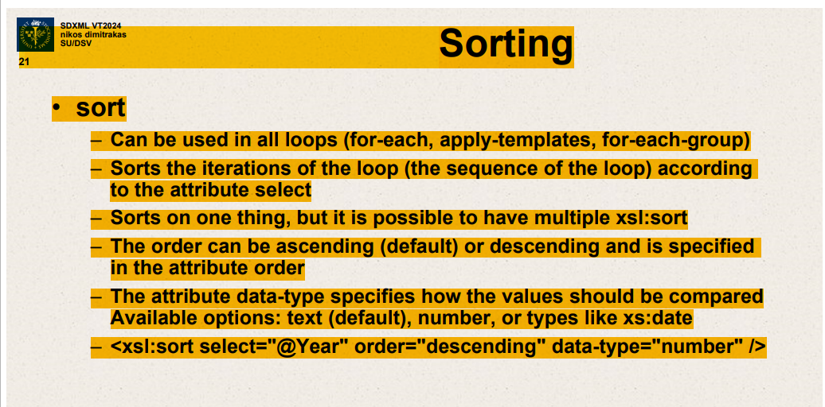

Sort – used in all loops (for-each ,apply-templates,for-each-group)

Sorts iterations of loop according to attribute select.

for-each-group

groups items in sequence that is result of Xpath expression in attribute select according to expression in attribute group-by.

current-group() – sequence containing all items of current group.

current-grouping()-key() – grouping value of current group.

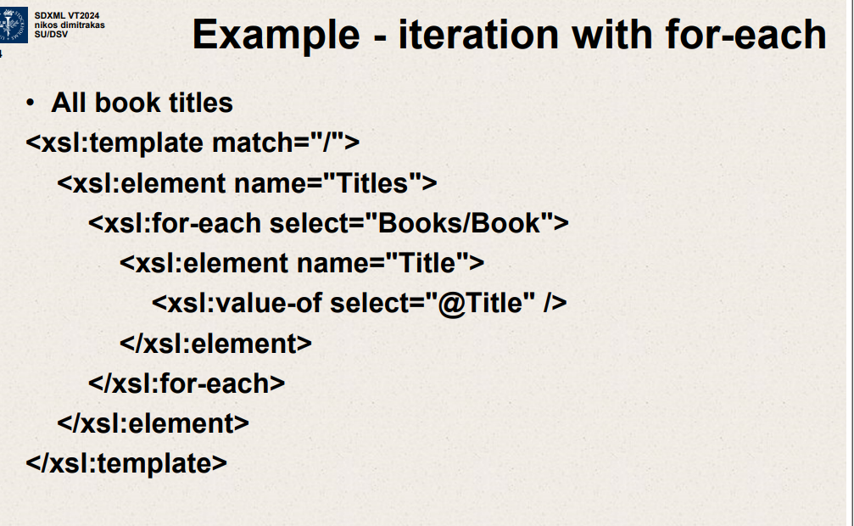

* The XSLT snippet is set to match the root node of the XML (**match="/"**), which is the starting point for the template.
* It creates a new element **<Titles>** that will wrap all the individual title elements.
* Within the **<Titles>** element, an **xsl:for-each** loop is set up to select each **<Book>** element nested within **<Books>**.
* For each **<Book>** element selected, it creates a new **<Title>** element.
* Inside each **<Title>** element, it uses **xsl:value-of** to extract the value of the **Title** attribute from the current **<Book>** element in the iteration and places this value inside the **<Title>** element.
* The loop will repeat for each **<Book>** in the **<Books>** node set, creating a list of **<Title>** elements, each containing the title of a book.
* Finally, the **for-each** loop closes, followed by the closing tag for the **<Titles>** element.

The end result will be a new XML structure with a **<Titles>** element containing a list of **<Title>** elements, each with the title of a book from the original XML document. This is a typical pattern for transforming XML data into a new structure with XSLT.

**The <xsl:template match="/"> in XSLT is a template rule that matches the root node of an XML document.**

Root node is top level node

The **match="/"** attribute in an **<xsl:template>** element tells the XSLT processor to apply this template when it is at the root node. This is often used to begin the processing of the XML document.

Inside this template, you would typically include XSLT instructions that you want to execute starting from the top level of the document. For instance, you might set up the structure of the resulting document or apply templates to child nodes.